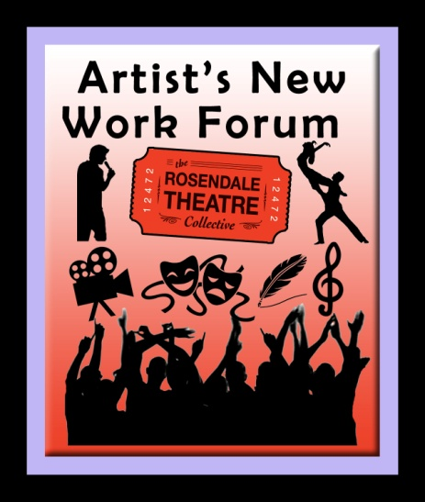
Artist's New Work Forum

Audience Survey

Title

Date

Please take a moment to let us know how you feel about the show. Thank you.

("X" one)
1. What was your reaction to the show overall?
Excellent
Very Good
Good
Fair
Poor

2. Would you recommend this to your friends?

Yes, Definitely
Yes, Probably
No, Probably Not
No, Definitely Not

5. How would you rate each of the following elements? Scale of 1 to 3 (3 being best) or
n/a (Not applicable) Feel free to write a brief comment in the box.

Characters
The story
The action
The suspense
The scariness
The settings
The pace
The length
The music
The ending

13.What is your gender? _________________

14. Please indicate your age group by circling the number:

Under 12 | 30 to 34
12 to 14 | 35 to 39
15 to 17 | 40 to 44
18 to 20 | 45 to 49
21 to 24 | 50 to 59
25 to 29 | 60 & over

6. Which of the following words or phrases best describe the movie? (PLEASE MARK ("X") ON AS MANY AS APPLY.)

Entertaining |  | Intense |  | Emotionally satisfying
Boring/Dull |  | Confusing |  | Different/original
Dramatic |  | Has a good story |  | Well paced
Powerful |  | Not my type of movie |  | Too slow in spots
Fun |  | Too predictable |  | Too fast in spots
Scary |  | Interesting characters |  | Good music
Interesting |  | Lacks compelling characters |  | Add your own words/phrases
Uplifting |  | Sympathetic characters
Innovative |  | Thought-provoking
Done before |  | Gripping

(Please be as specific as possible in your description of the scenes.)

3. Please list what part of this evening drew you in the most.

4. Please list what part of this evening pushed you out the most.

5. What, if anything, did you find confusing about the show that was not cleared up by the end?

6. Any additional comments are welcome:

