Application 2017: Artist's New Work Forum
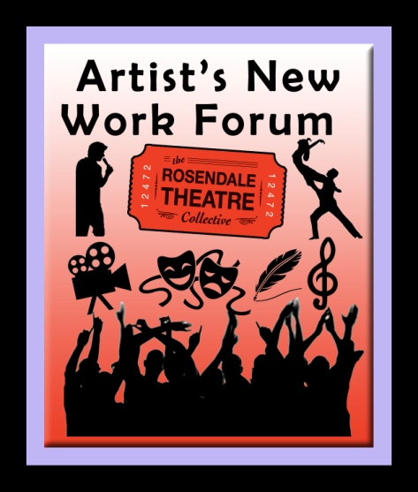

Artist’s New Work Forum provides an opportunity for artists, who may not have other opportunities or access to audiences, to present and workshop new work or works-in-progress to the public free of charge in the Rosendale Theatre.

Detailed information and policy guidelines are located on our website: http://www.rosendaletheatre.org/artists-new-work-forum/

Complete this form and email it as a word doc or RTF (NO PDFs!) to TheRosendaleTheatre@gmail.com

(Contact info will not be made public)

CONTACT NAME:

EMAIL ADDRESS: Important, ALL communication will be through this email!

PHONE NUMBER:

MAILING ADDRESS: Street, Apt #, Town, State, Zip Code, COUNTY

HOW DID YOU HEAR ABOUT US? Please place an X in front of the choice
Advertisement
Trade Journal
Flyer/Postcard
Newspaper
Word of Mouth
Social Media
Other

TITLE OF WORK:

WHAT IS YOUR ROLL IN THIS PROJECT?

SYNOPSIS: Please describe your piece (under 50 words)

IN ONE SENTENCE DESCRIBE YOUR WORK:
- one sentence only!

ARTISTIC STATEMENT: Please give us a sense of why and how your project is being made. Communicate the purpose of the project (up to 250 words).
RUNNING TIME (hours/minutes/seconds)

SHORT BIO OF ARTIST(S):

WHAT STAGE OF COMPLETION IS YOUR PROJECT?

PROVIDE A LIST OF OTHER PROJECTS YOU'VE WORKED ON, IF ANY.

ARTISTIC DISCIPLINE: Please put an X in front of one category that best fits the work you're submitting
Film/Video (feature film, short film, documentary)
Theater, Play, Staged Reading
Dance / Choreography
Musical Theater, Opera
Performance Art
Monologue
Other:

SUBMIT YOUR WORK: Email your script, choreographers can provide links to previous work if current work is unavailable, musicians can send links to audio or video files. Filmmakers upload your work to Youtube or Vimeo and provide the URL address below so that we may preview it. The other option is to mail us a DVD, in that case, please write "in-mail" below. INCLUDE a self-addressed-stamped-envelope if you wish it returned. Mail to: Rosendale Theatre, PO BOX 545, Rosendale, NY 12472
Provide the URL links and describe your submission here:

Detailed information and policy guidelines are located on our website: http://www.rosendaletheatre.org/artists-new-work-forum/
I HAVE READ THE POLICY GUIDELINES AND AGREE TO THE TERMS. *
Please place an X in front of agree or do not agree.
Yes, I agree
No, I do not agree

Thank you for filling out this application.
Please save it as a word doc or in rich text format (no PDFs!) and email it to: TheRosendaleTheatre@gmail.com Subject line: "Artist's New Work Forum"

