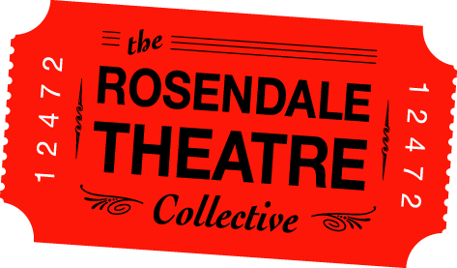
MARKETING CHECKLIST
CHECKLIST:
- Press Release
- RTC Website Listing
- E-Newsletter
- Interviews for e-newsletter?
- Poster (27" x 40")
- Fliers (8.5" x 11")
- Postcards (4" x 6")
- Social Media (Facebook, Twitter)
- Trailer (2 minutes or less)
- Newspaper/Magazine Print Advertisements
- Rosendale Theatre's Pre-Show Ad ($75 per month)
- Other
Email this form to StephEllis1024@gmail.com and CC: info@RosendaleTheatre.org SIX WEEKS before your event. All productions, rentals and co-productions, are promoted through the Rosendale Theatre's printed calendar, website, facebook page, e-newsletter and twitter account. Posters/flyers are displayed in the theatre lobby and moved to the outside poster case on the week of event.
Include Rosendale Theatre ticket logo in all marketing materials.

Contact info (not for public)
Name:
Phone Number:
Email:

Name of the Event:
Date(s) of the Event:
Marketing Deadline - 6 weeks before event date:
Time(s) of the Event:
Duration (hours/minutes):
Admission Price(s) (General admission, Members, Students, Children under 12, seniors):
Rating (G, PG, R):
Description of the event and/or press release:
Advanced Ticket Sale Price (if different):

Advance Ticket Sales Location(s) Note: The Rosendale Theatre does not offer advanced ticket sales in our box office:

Advance Ticket Sales Online Link:

Sponsors for this event:

Event Terms (ie Rental, RTC produced, Co-production):

INCLUDE EMAIL ATTACHMENTS of photos or artwork for the event - high resolution, 300 dpi - Poster, Flyers, Sponsor's Logo, Headshots, etc.

